# **SOFTWARE TESTING ASSIGNMENT**

## {Module-1(Fundamental)}

==================================================================================

# * What is SDLC(software development life cycle) ?

- A software devlopment life cycle is essentially a series of steps or phases that provides a model for the development and lifecycle management of an application or piece of software.

- A software development life cycle means starting to end process of devlopment application and software.

- **TOTAL SIX PHASES ARE THERE:-**

1)Requirements collection/gathering

{establish customer needs}

2)Analysis "what"

{model and specify the requirements}

3)Design "why"

{model and specify a solution}

4)Implementation

{construct a solution in software}

5)Testing

{validate the solution against the requirements}

6)Maintenance

{repair defects and adapt the solution to the new requirements}

-------------------------------------------------------------------------------------------------------------------------------

# * What is software testing?

- **S**oftware testing is process used to identify the correctness,completness and quality of developed computer software.

- **T**esting can be defined as a process of analayzing a software item to detect the diffrences b/w existing and required conditions.

---------------------------------------------------------------------------------------------------------------------------------

# * What is agile methodology ? [done quick]

- It is a combination of iterative and increment model.

- It divides the software into small incremental builds, this build are provided in iteration that means the big projects are divided into the small chunks (iterations).

- Each iteration last about one to three weeks.

- Each iteration involves all the team member working simultaneously on areas like planning, requirement, analysis, design, coding, unit testing, and acceptance testing.

- At the end of the iteration working product is displayed stake holder and it’s is released in the market.

- After the release we check for the feedback of the deployed software.

- if any enhancement is needed in the project then it's done and it's re-released.

-------------------------------------------------------------------------------------------------------------------------------------

# * What is SRS ?(software requirement specification)

- A software requirement specifiction is complete description of the behaviour of the system to be developed.

- It includes a set of use cases that describe all of the interactions that users will have with the software.

- use cases are also known as functional requirements. in addition to use cases,the SRS also contains nonfunctional (or supplementary) requirements.

- Non-functional requirements are requirements which impose constraints on the design or implementation(such as performance requirements ,quality standards,or design constraints )

-Requirements are categorized in several ways.

.Customer requirements

.Functional requirements

.Non-Functional requirements

--------------------------------------------------------------------------------------------------------------------------------------

# *What is oops?

- Object oriented programming is way of writing the programs in organized way objects are like a black box where data are hidden.

--------------------------------------------------------------------------------------------------------------------------------------

# *Write Basic Concepts of oops?

- Concepts of Object oriented programming :-

**=> CLASS**

**=> OBJECT**

**=> ENCAPSULATION**

**=> INHERITANCE**

**=> POLYMORPHISM**

. **Overriding**

. **Overloading**

**=> ABSTRACTION**

-------------------------------------------------------------------------------------------------------------------------------------

# *What is Object?

- Object gives the permission to access functionality of class.

-------------------------------------------------------------------------------------------------------------------------------------

# *What is Class?

- Class is a collection of data member and member function.

--------------------------------------------------------------------------------------------------------------------------------------

# *What is encapsulation ?

- The process wrapping the data in a single unit. To secure the data from outside world .

--------------------------------------------------------------------------------------------------------------------------------------

# *What is inheritance ?

- Making a class from an existing class.Derving the attribute of some other class.

--------------------------------------------------------------------------------------------------------------------------------------

# *What is polymorphism?

- "one name multiple form" Polymorphism means "having many forms".

- The ability to change form is known as polymorphism.

- There is two types of ploymorphism in java.

* compile time polymorphism {OVERLOADING}

* Runtime polymorphism {Overriding}

-----------------------------------------------------------------------------------------------------------------------------------

## *Draw usecase diagram on online bill payment system(paytm).

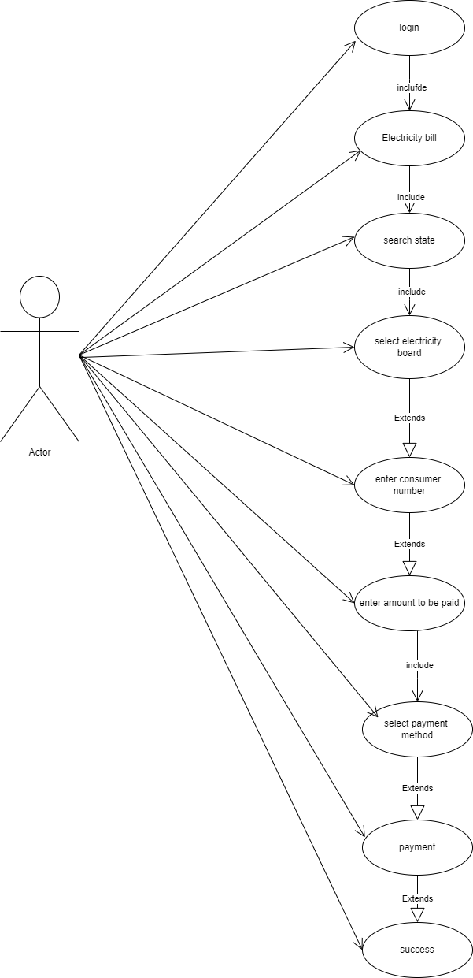

# * Draw usecase on online book shopping.

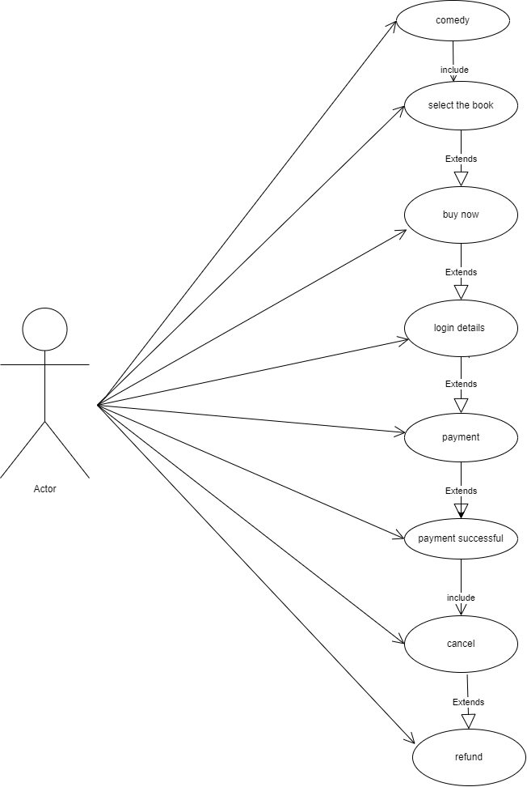

# * Write SDLC phases with basic introduction?

**-> TOTAL SIX PHASES ARE THERE:-**

**1)Requirements collection/gathering**

**{establish customer needs}**

**2)Analysis "what"**

**{model and specify the requirements}**

**3)Design "why"**

**{model and specify a solution}**

**4)Implementation**

**{construct a solution in software}**

**5)Testing**

**{validate the solution against the requirements}**

**6)Maintenance**

**{repair defects and adapt the solution to the new requirements}**

**-> Requirement gathering**

Requirement will changes

- Types of requirement:-

* functional requirement: describe system services or functions.

. compute sales tax on a purchase

. update the database on the server

* non-functonal requirement: are constraints on the system or the development process

non-function requirements may be more critical than functional requirements

**-> Analysis phase**

. This analysis represent the "what" phase.

. This phase starts with the requirement document delivered by the requirement phase and maps the requirement into architecture.

. Architecture defines the components their interface & behaviours.

. Deliverable design document is the architecture.

**-> Design phase**

. Design architecture document.

. Implementation plan.

. critical priority analysis.

. performance analysis.

. Test plan

**->Implementation phase**

.In the implementation phase the team builds the component either from scratch or by composition.

*Implementation -code.

*Critical error removal.

. The implementation phase deals with the issues of quality ,performance, baselines, libraries & debugging.

**->Testing phase**

. simply stated,quality is very important many companies have not learned that quality is important and deliver more claimed functionality but at a lower quality level.

. A customer satisfied with the quality of product will remain loyal & wait for new functionality in the next version.

* REGRESSION TESTING

* INTERNAL TESTING

* UNIT TESTING

* APPLICATION TESTING

* STRESS TESTING

**-> Maintenance phase**

. Corrective maintenance

{identifying & repairing defects}

. Adaptive maintenance

{adaptive the existing solution to the new platforms}

. Perfective maintenance

{implementing the new requirements}

------------------------------------------------------------------------------------------------------------------------------------

# * Explain phases of the Waterfall model?

- As the name waterfall model implies this model's process of downward mechanism is similar to that waterfall.

- The whole process is divided into sequential stages, and it is imperative to complete each phase successfully in order to move onto the next one.

-> Waterfall model phases:

* Reuirements * Implementation

* Analysis * Testing

* Design * Maintenance

# * Write Phases of spiral model?

- Spiral model is very widely used in the software industry as it is in synch with the natural development process of any product.

- For medium to high risk projects.

- The spiral model has four phases:

* Planning

* Risk analysis/design

* Engeneering/Construct/Development

* Evalution

--------------------------------------------------------------------------------------------------------------------------------------

# *Explain working methodology of agile model and also write pros and cons.

- It is a combination of iterative and increment model.

- It divides the software into small incremental builds, this build are provided in iteration, that means the big project are divided into small chunks (iterations).

- Each iteration last about one to three weeks.

- Each iteration involves all the team member working simoultaneously on areas like planning, requirement, analysis, design, coding, unit-testing and acceptance testing.

- At the end of the iteration the working product is displayed to the customer or the important stake holder and its is released in the market.

- After the release we check for the feedback of the deployed software.

- If any enhancment is needed in the project then it's done and it's re-released.

**=> Pros (Advantages)**

1) Frequent delivery

2) Face to Face communication with the customer

3) Less time

4) Adaptability

**=> Cons (Disadvantages)**

1) Less documentation

2) Maintanence problem

------------------------------------------------------------------------------------------------------------------------------------

# *Draw usecase on Online Shopping Product using COD.

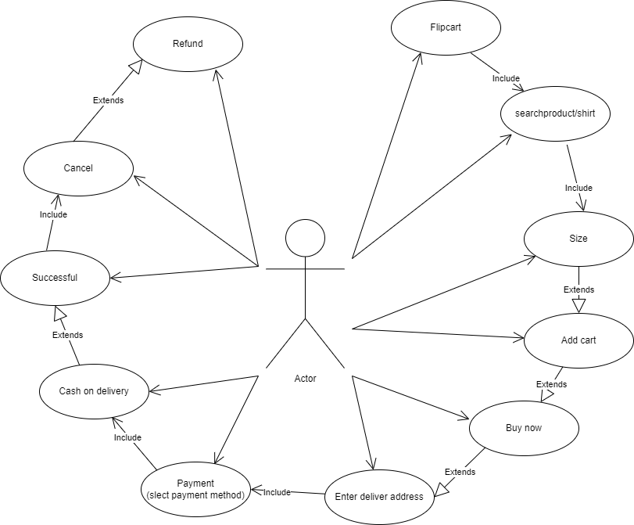

--------------------------------------------------------------------------------------------------------------------------------------

# *Draw usecase on online shopping product using payment gateway.



